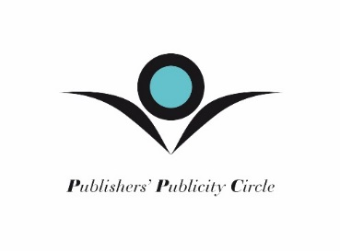

PPC AWARD CATEGORY DEFINITIONS

- Hardback non-fiction
Award for the best campaign for a work of general non-fiction, published in hardback in its first edition.

- Hardback fiction
Award for the best campaign for work of fiction, published in hardback in its first edition.

- Celebrity
Award for the best campaign for a book in any format/edition (including fiction, memoir, autobiography, essays or graphic novel) written or co-written by a well-known personality.

- Debut
Award for the best campaign for a first publication in the United Kingdom or Republic of Ireland for an author of fiction, non-fiction or poetry, in any format. If an author has previously had works made available in the UK market (i.e. on import from another English language territory) or had works translated and accessible to UK consumers, they would not be considered a debut for the purposes of this category.

- YA and Children’s Celebrity Book Campaign (all formats)
Award for the best campaign for a book aimed at a young reader (including picture books, middle grade and teen) written by a well-known personality.

- Crime and Thriller Campaign, hardback and paperback
Award for the best book campaign within the crime, psychological suspense or thriller genre. This can be a novel or non-fiction, including true crime narratives, in both hardback and paperback format.

- Lifestyle, gift and humour
Best campaign for a work of non-fiction in hardback, trade paperback or paperback format, within lifestyle publishing (not cookery), gifting and humour genres.

- Cookery
Award for the best campaign publicising a cookbook in its first edition.

- Generic
Award for the best literary campaign that is not solely related to a publication launch; including promotion of awards, festivals, literacy initiatives, book-to-screen projects and anniversary publishing.

- Paperback
Award for the best campaign for a work of non-fiction or fiction, published in paperback as either first or second format

- Academic
Award for the best campaign for a work of non-fiction in its first edition, written by a specialist or academic writer, and/or published by an education publisher

- Children’s
Award for the best campaign for a work of fiction or non-fiction aimed at a young reader (including picture books) aged below 12 years.

- YA
Award for the best campaign for a work of fiction or non-fiction aimed at a young reader aged 12 years and above.

- Sport
Award for the best work of non-fiction about a sporting event, discipline or personality; and/or written by a sporting professional

- Newcomer
Award for the best (solo) campaign by a publicist with 2 years or less publicity experience. A campaign in this category may also be submitted into one other relevant category.

